Benha University
Faculty of engineering (Shoubra) Model Answer
ECE 447: Robotics Engineering Quiz No. 2 (Time: 45 min)
Name: Department: ECE / CSE
Please note, this is a one of many possible solutions according to the assignment of the frames.
For the shown UR10 robotic manipulator, assign the coordinate frames on the right projection. Fill the DH table below.

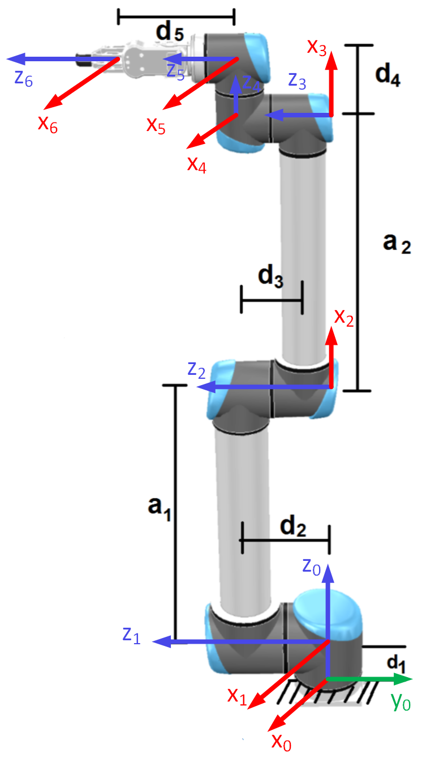
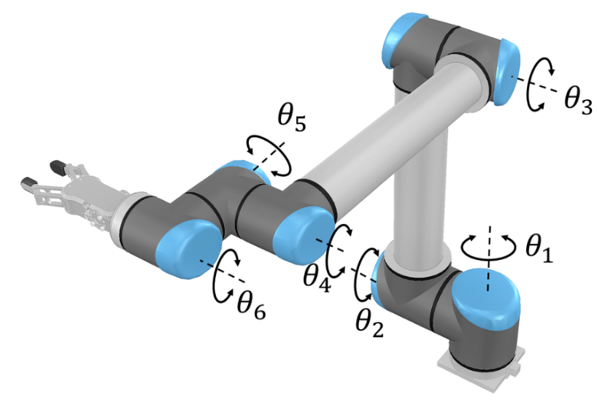

Link | a | α | d | θ
1 | 0 | +90 | $$d_{1}$$ | $${θ_{1}}^{*}$$
2 | $$a_{1}$$ | 0 | 0 | $${θ_{2}}^{*}$$
3 | $$a_{2}$$ | 0 | 0 | $${θ_{3}}^{*}$$
4 | $$0$$ | -90 | $$d_{2}$$ | $${θ_{4}}^{*}$$
5 | 0 | +90 | $$d_{4}$$ | $${θ_{5}}^{*}$$
6 | 0 | 0 | $$d_{5}$$ | $${θ_{6}}^{*}$$
DH Table
__________________________________________
DH terms:
